ML Lab Assignment 1
Program Code:
import numpy as np
import matplotlib.pyplot as plt
plt.rcParams['figure.dpi'] = 100
# x is number of hours spent in driving
x = [10,9,2,15,10,16,11,16]
x = np.array(x)
# y is a factor denoting possibility of acute back ache
y = [95,80,10,50,45,98,38,93]
y = np.array(y)
plt.xlabel("hours spent in driving")
plt.ylabel("acute back ache risk factor")
plt.scatter(x,y)
plt.show()
# execute till here in one code cell
mean_x = np.mean(x)
mean_y = np.mean(y)
# Total number of values
n = len(x)
# Using the formula to calculate m and c
numer = 0
denom = 0
for i in range(n):
numer += (x[i] - mean_x) * (y[i] - mean_y)
denom += (x[i] - mean_x) ** 2
m = numer / denom
c = mean_y - (m * mean_x)
# execute till here in one code cell
print("m = "+str(m)+"\nc = "+str(c))
p1 = m*(-2) + c # y at x = 0

p2 = m*20 + c # y at x = 16
x2 = np.array([0,20])
y2 = np.array([p1,p2])
plt.xlabel("hours spent in driving")
plt.ylabel("acuteback ache risk factor")
plt.scatter(x,y)
plt.plot(x2,y2, '-y')
plt.grid()
plt.xlim(0,18)
plt.show()

Output:

ML Lab Assignment 2
Program Code:
#import packages
import pandas as pd
import numpy as np

# Read dataset
dataset=pd.read_csv("tree1.csv")

x=dataset.iloc[:,:-1]
y=dataset.iloc[:,5]

#Label encoder
from sklearn.preprocessing import LabelEncoder
le=LabelEncoder()
x=x.apply(le.fit_transform)
print(x)

# 1 1 0 0

#import Decesion Tree Classifier

from sklearn.tree import DecisionTreeClassifier
# Create decision tree classifer object
regressor=DecisionTreeClassifier()
# Train model
regressor.fit(x.iloc[:,1:5],y)

x_in=np.array([1,1,0,0])
y_pred=regressor.predict([x_in])

print(y_pred)

import six
import sys
sys.modules['sklearn.externals.six'] = six
from sklearn.externals.six import StringIO
#from IPython.display import Image
from sklearn.tree import export_graphviz
import pydotplus
from io import StringIO

dot_data=StringIO()
export_graphviz(regressor,out_file=dot_data,filled=True,rounded=True,special_characters=True)

#Draw Graph
graph=pydotplus.graph_from_dot_data(dot_data.getvalue())

# Show graph & Create png File
graph.write_png("tree.png")

Output:

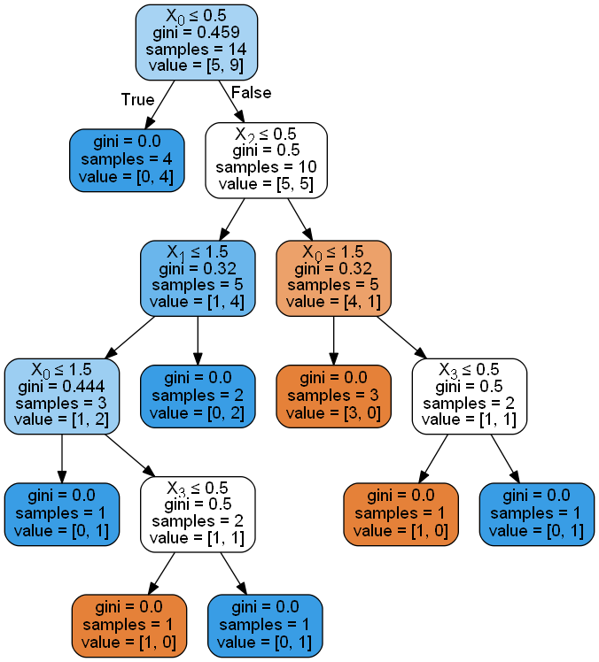

ML Assignment 3
Program Code:
#import the packages
import pandas as pd
import numpy as np

#Read dataset
dataset=pd.read_csv("kdata.csv")
X=dataset.iloc[:,:-1].values
y=dataset.iloc[:,2].values

#import KNeighborshood Classifier and create object of it
from sklearn.neighbors import KNeighborsClassifier

#Creating model
classifier=KNeighborsClassifier(n_neighbors=3)
# Training model
classifier.fit(X,y)

#predict the class for the point(6,6)
X_test=np.array([6,6])
# Predictions for test data
y_pred=classifier.predict([X_test])
print(y_pred)

# KNeighborsClassifier looks for the 5 nearest neighbors
#If set to uniform, all points in each neighbourhood have
#equal influence in predicting class i.e. predicted class is the class with highest number of points in the neighbourhood.
classifier=KNeighborsClassifier(n_neighbors=3,weights='distance')
classifier.fit(X,y)

#predict the class for the point(6,6)
X_test=np.array([6,2])
y_pred=classifier.predict([X_test])
print(y_pred)

Output:

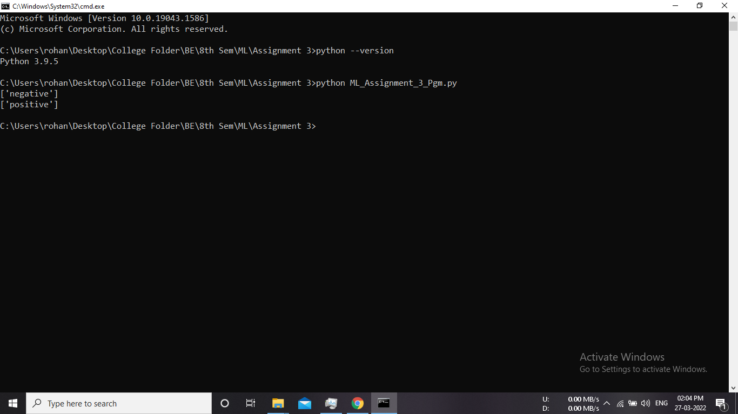

ML Assignment 4
Program code:
#import packages
import numpy as np
import matplotlib.pyplot as plt
import pandas as pd
#create dataset using DataFrame
df=pd.DataFrame({'X':[0.1,0.15,0.08,0.16,0.2,0.25,0.24,0.3],
'y':[0.6,0.71,0.9,0.85,0.3,0.5,0.1,0.2]})
f1 = df['X'].values
f2 = df['y'].values
X = np.array(list(zip(f1, f2)))
print(X)
#centroid points
C_x=np.array([0.1,0.3])
C_y=np.array([0.6,0.2])
centroids=C_x,C_y
#plot the given points
colmap = {1: 'r', 2: 'b'}
plt.scatter(f1, f2, color='k')
plt.show()
#for i in centroids():
plt.scatter(C_x[0],C_y[0], color=colmap[1])

plt.scatter(C_x[1],C_y[1], color=colmap[2])
plt.show()
C = np.array(list((C_x, C_y)), dtype=np.float32)
print (C)
#plot given elements with centroid elements
plt.scatter(f1, f2, c='#050505')
plt.scatter(C_x[0], C_y[0], marker='*', s=200, c='r')
plt.scatter(C_x[1], C_y[1], marker='*', s=200, c='b')
plt.show()

#import KMeans class and create object of it
from sklearn.cluster import KMeans
model=KMeans(n_clusters=2,random_state=0)
model.fit(X)
labels=model.labels_
print(labels)
#using labels find population around centroid
count=0
for i in range(len(labels)):
if (labels[i]==1):
count=count+1
print('No of population around cluster 2:',count-1)

#Find new centroids
new_centroids = model.cluster_centers_
print('Previous value of m1 and m2 is:')
print('M1==',centroids[0])
print('M1==',centroids[1])
print('updated value of m1 and m2 is:')
print('M1==',new_centroids[0])
print('M1==',new_centroids[1])

Output:

